**NIT3222 – Virtualisation in Computing**

**Lab 5**

***ID: Name: __________ __________***

In this lab we will create a simple network topology by using virtual networks. Either internal or private virtual networks will be suitable for this lab (refer to the lecture notes for more information).

1. Overview

The idea is to use two virtual networks on the host machine to create two subnets. The subnets are joined by the machine that is on both subnets (i.e. has two interfaces). See the figure below for the design of the virtual network.

Parent

Child 1

(Server OS)

Child 2

(Client OS)

Child 3

(Server OS)

Virtual Switch 1

Virtual Switch 2

192.168.1.2

255.255.255.0

192.168.1.1

255.255.255.0

192.168.2.1

255.255.255.0

192.168.2.2

255.255.255.0

**Host**

1. Strategy
   1. Create three virtual machines

To create a network, we must create virtual machines. Create another instance of the Windows Server operating system with 1024 MB RAM (making a total of 3 virtual machines). The easiest way is to clone Win2012R2.

* 1. Configure networking

Following the figure above, configure the network interfaces for each machine. The operating system in the middle requires two network interfaces. You can add an additional interface by using ‘Add Hardware’ in the settings for the virtual operating system. Note that the VM must be shut down before adding virtual hardware.

* 1. Enable routing

You can enable routing by starting the ‘Routing and Remote Access’ service in the services management console (services.msc).

* 1. Install web server

Install the web server on child 3 (see figure above). This is achieved by installing the ‘Web Server’ role. Then use an Internet browser to navigate to ‘192.168.2.2’.

Upon completion, demonstrate to the lecturer that machine with IP address ‘192.168.1.2’ can access the web server with IP address ‘192.168.2.2’

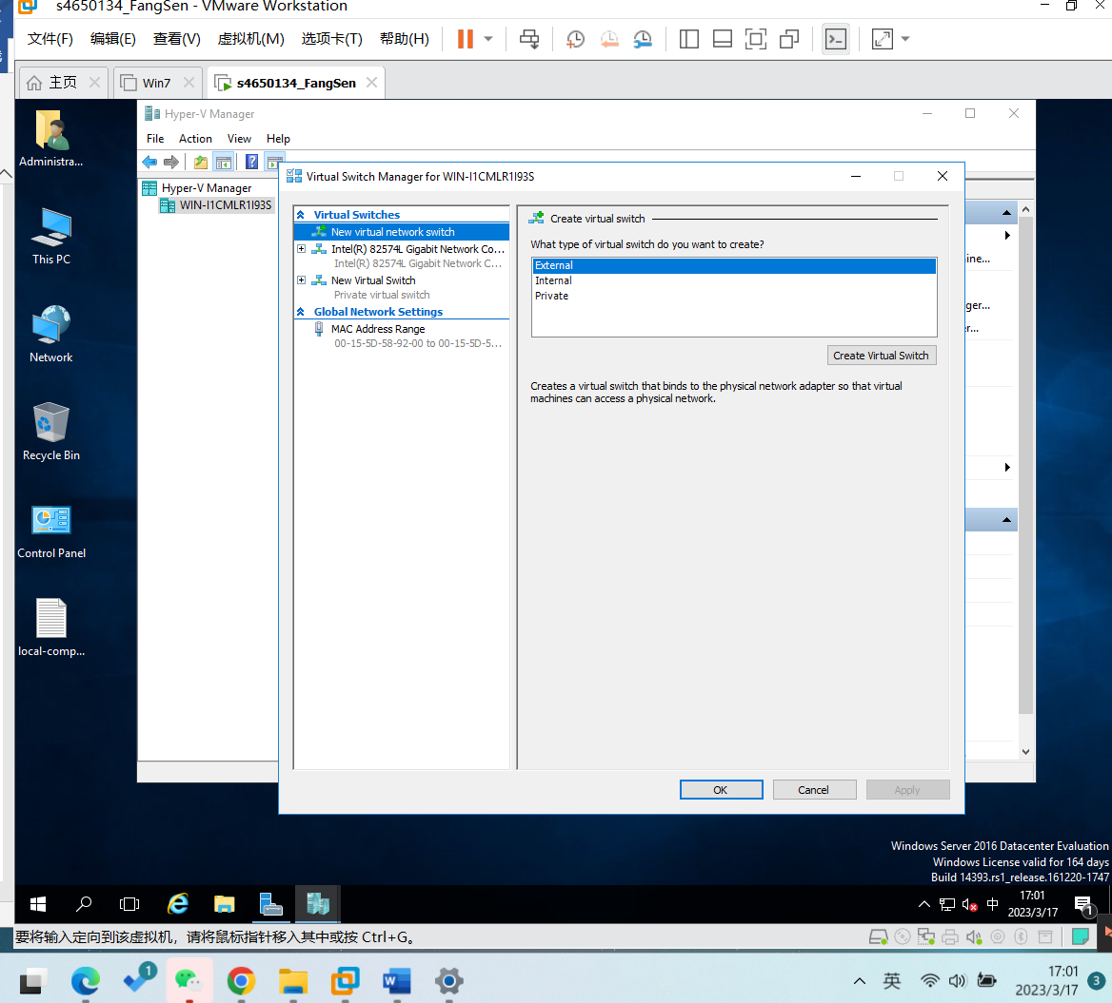

Figure

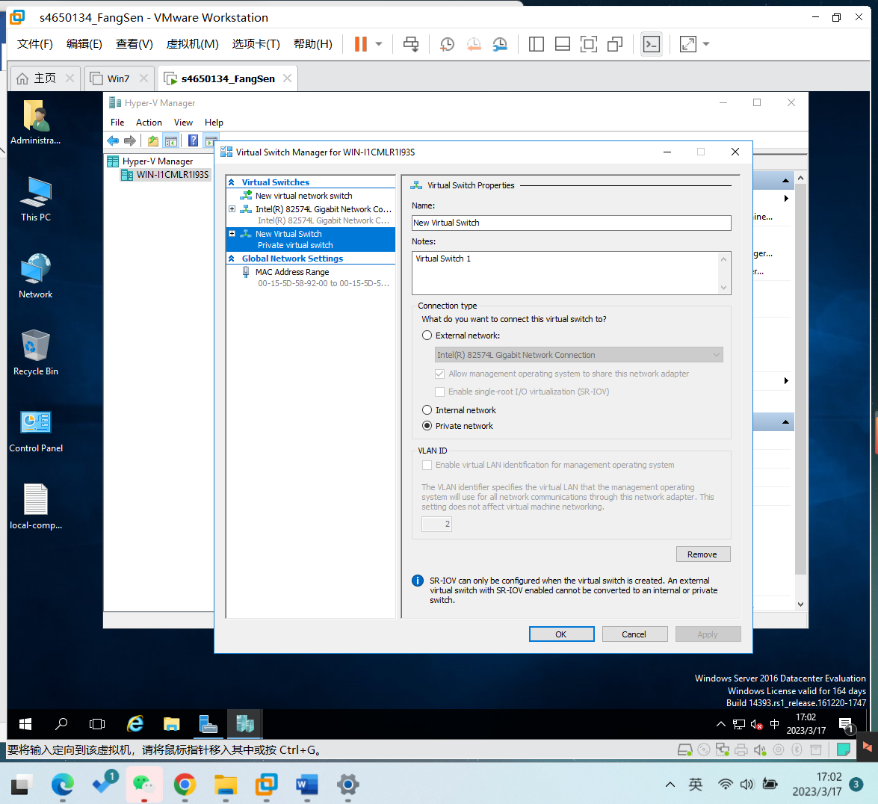

Figure

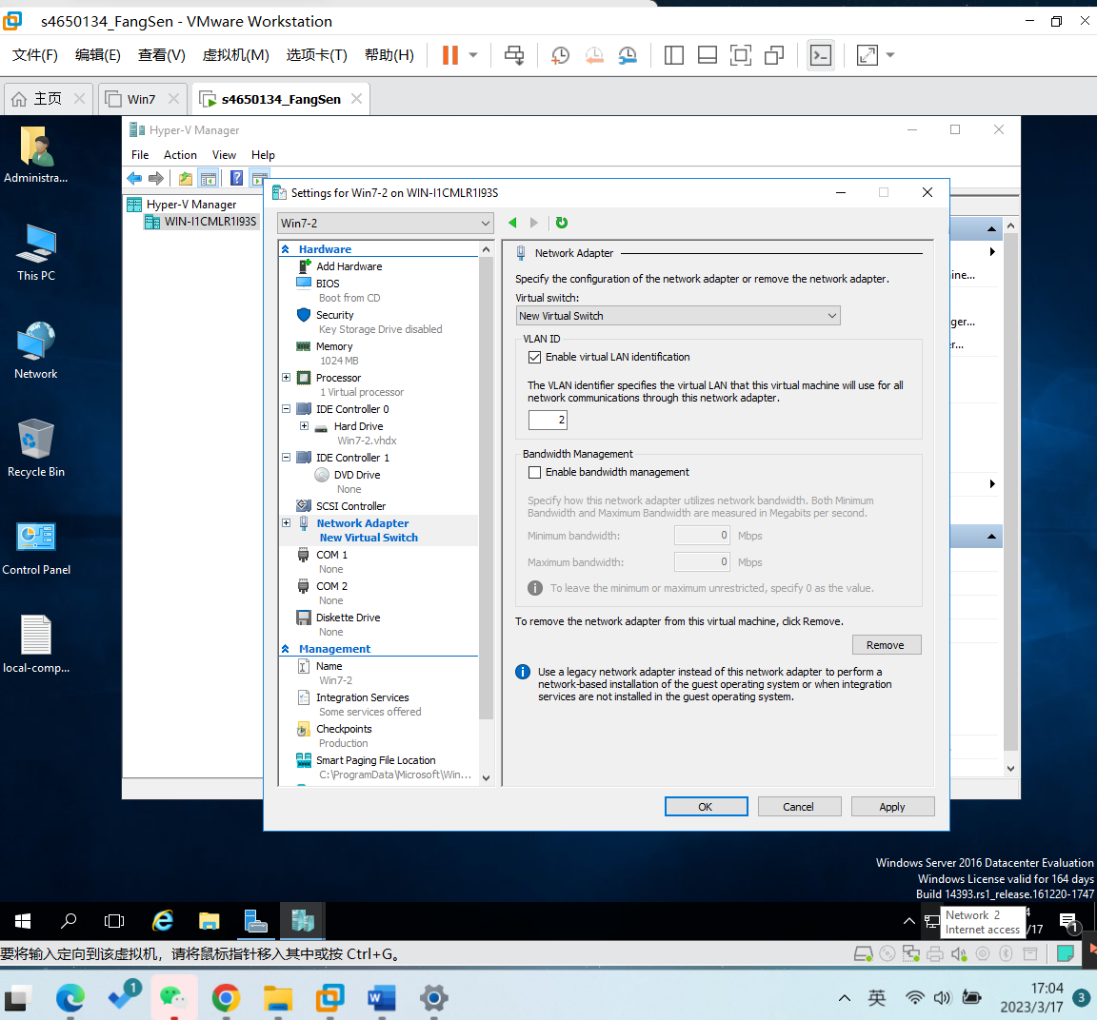

Figure

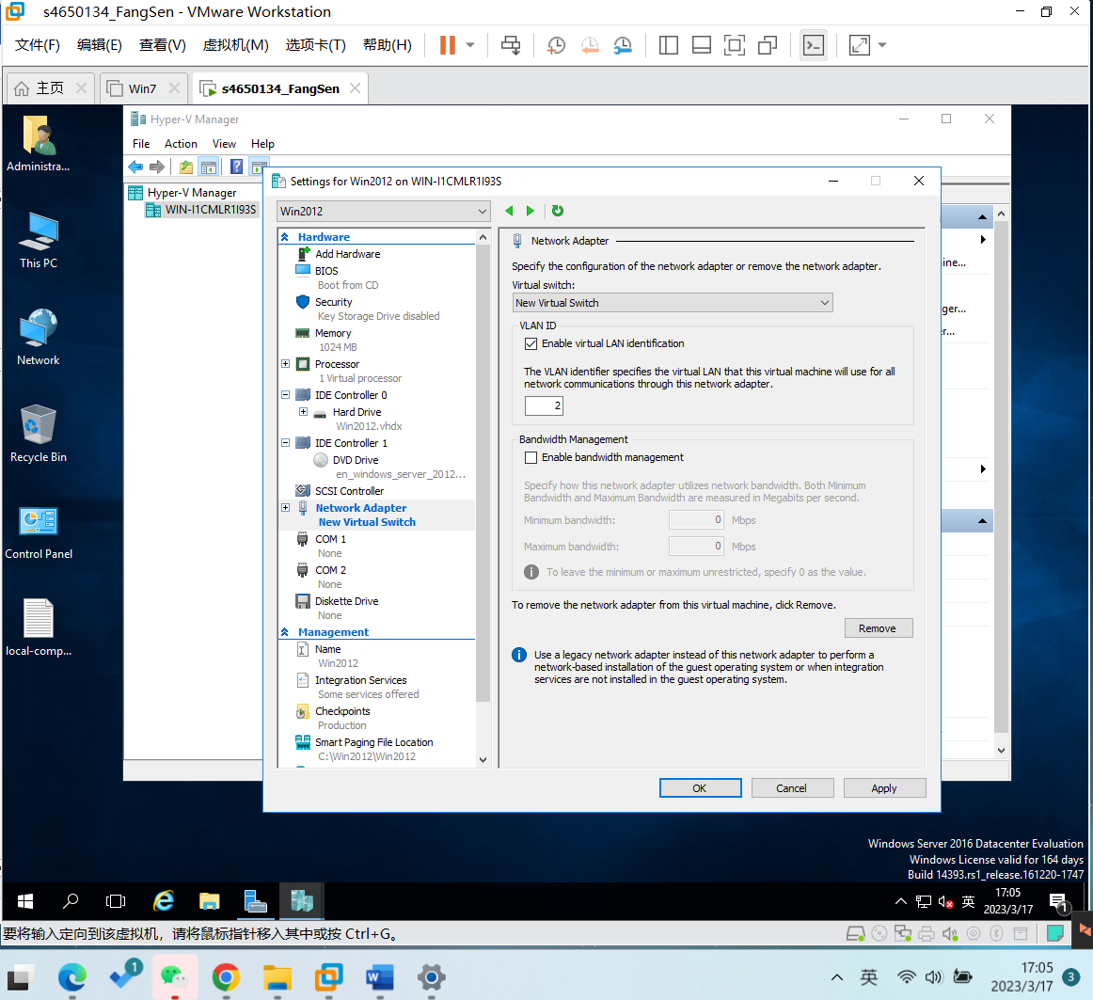

Figure

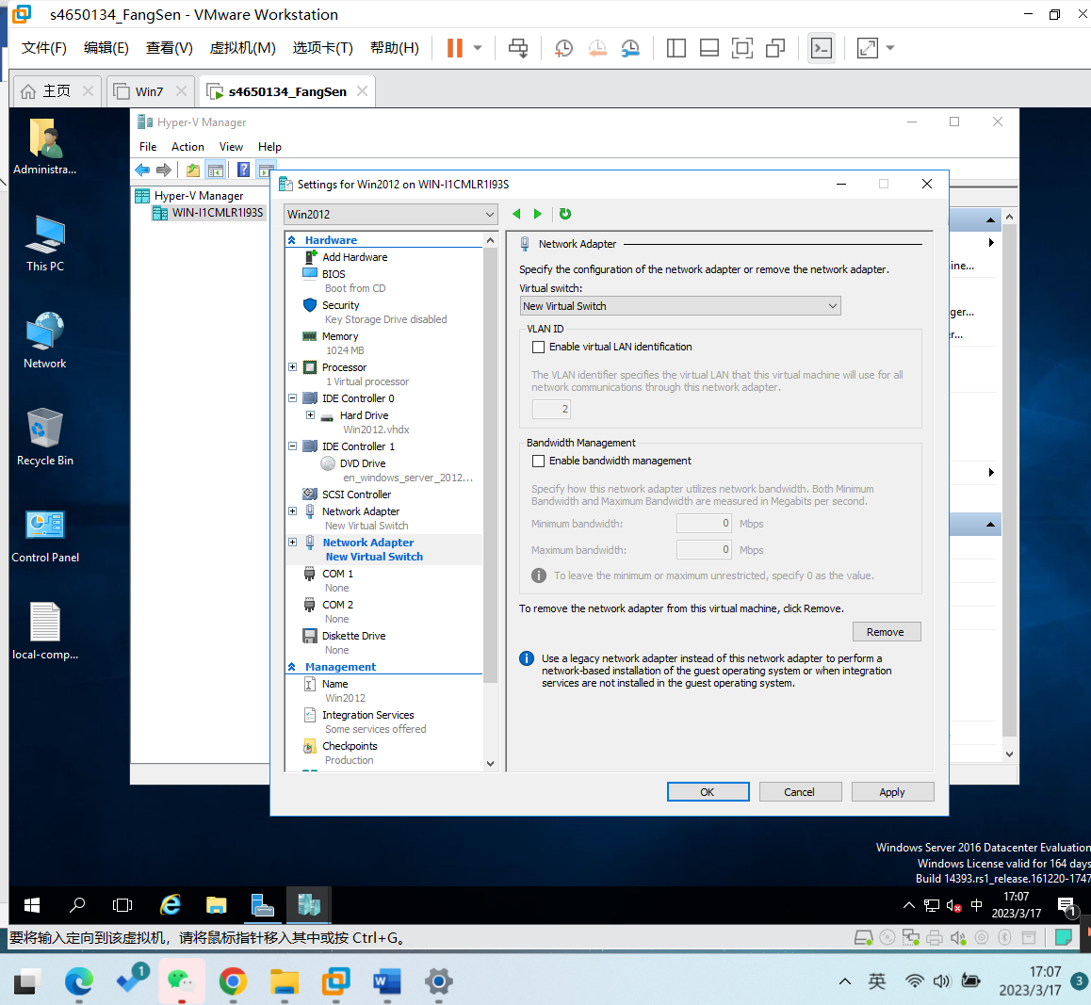

Figure

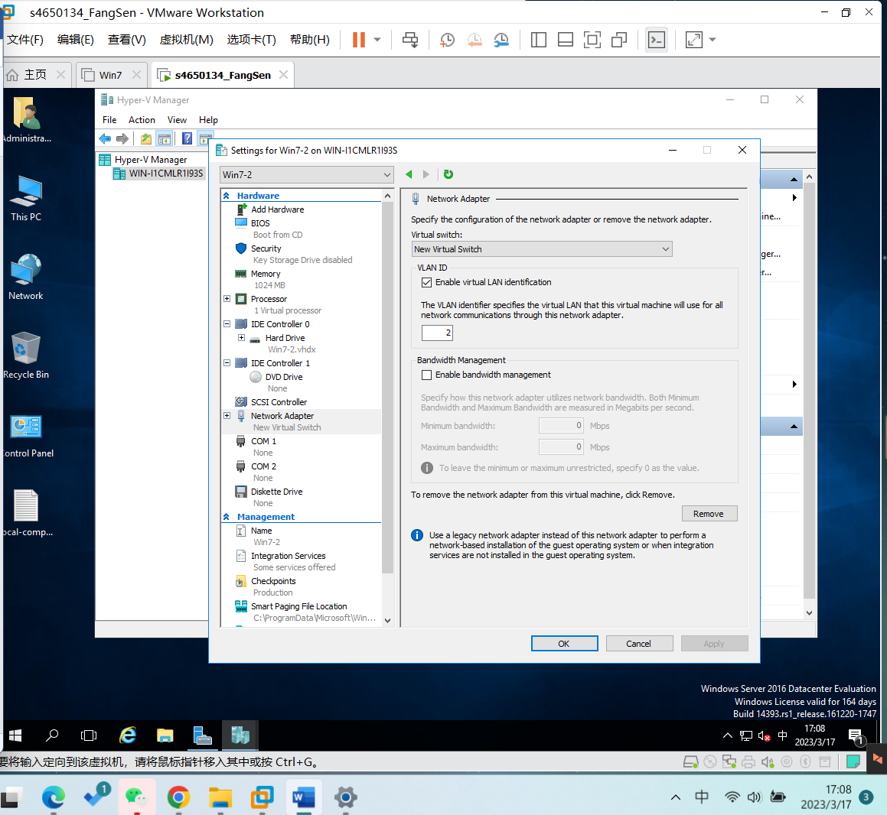

Figure

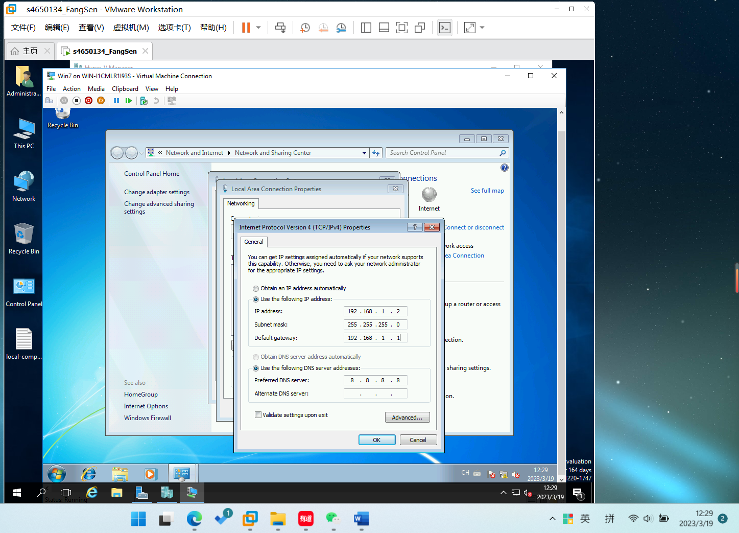

Figure

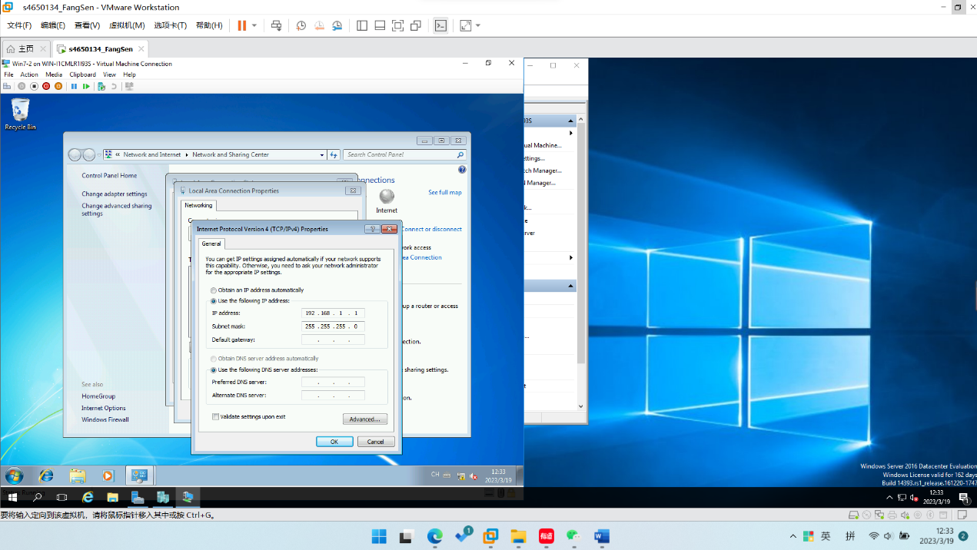

Figure

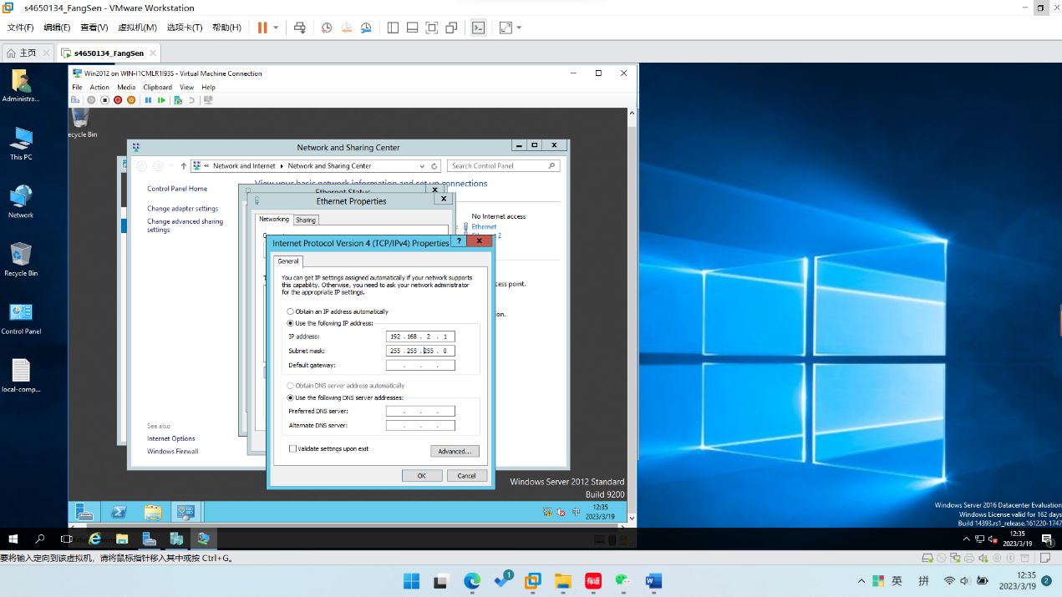

Figure

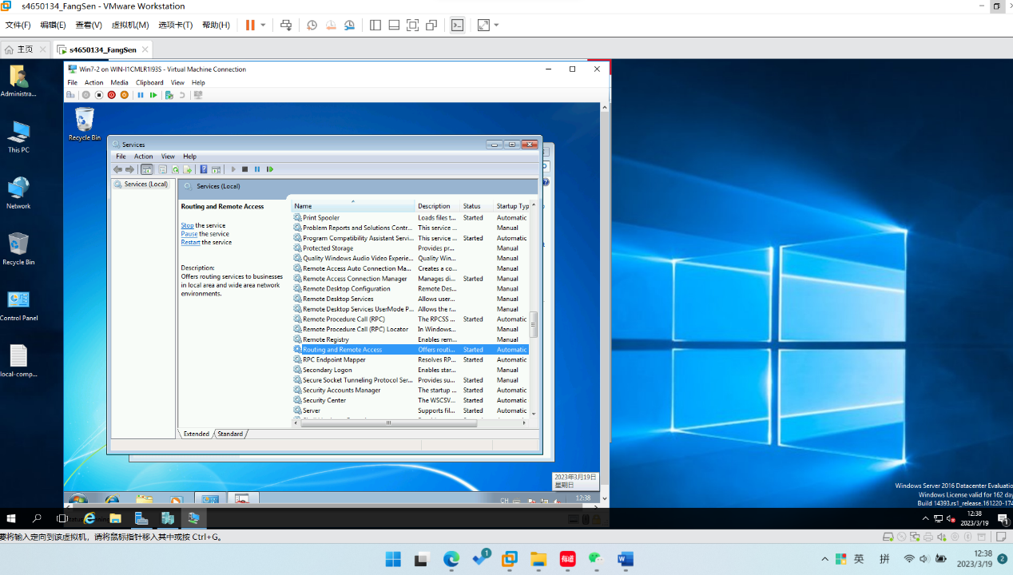

Figure

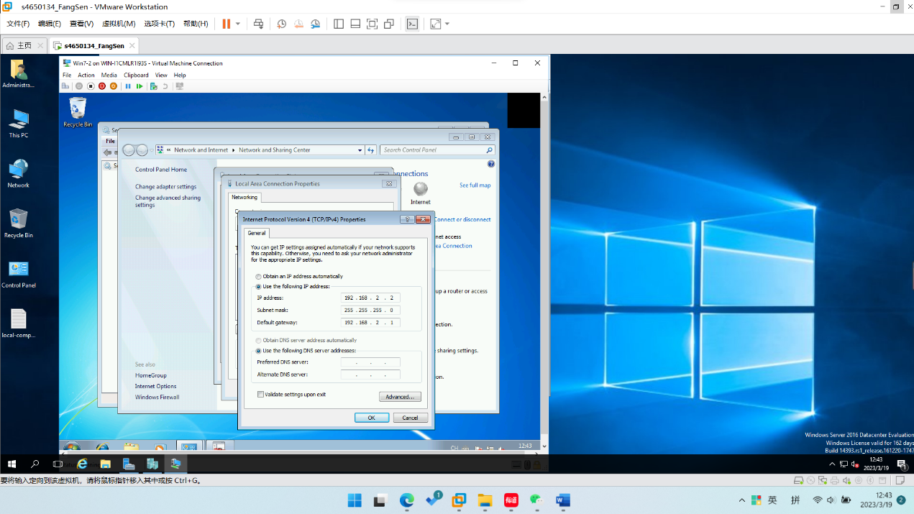

Figure

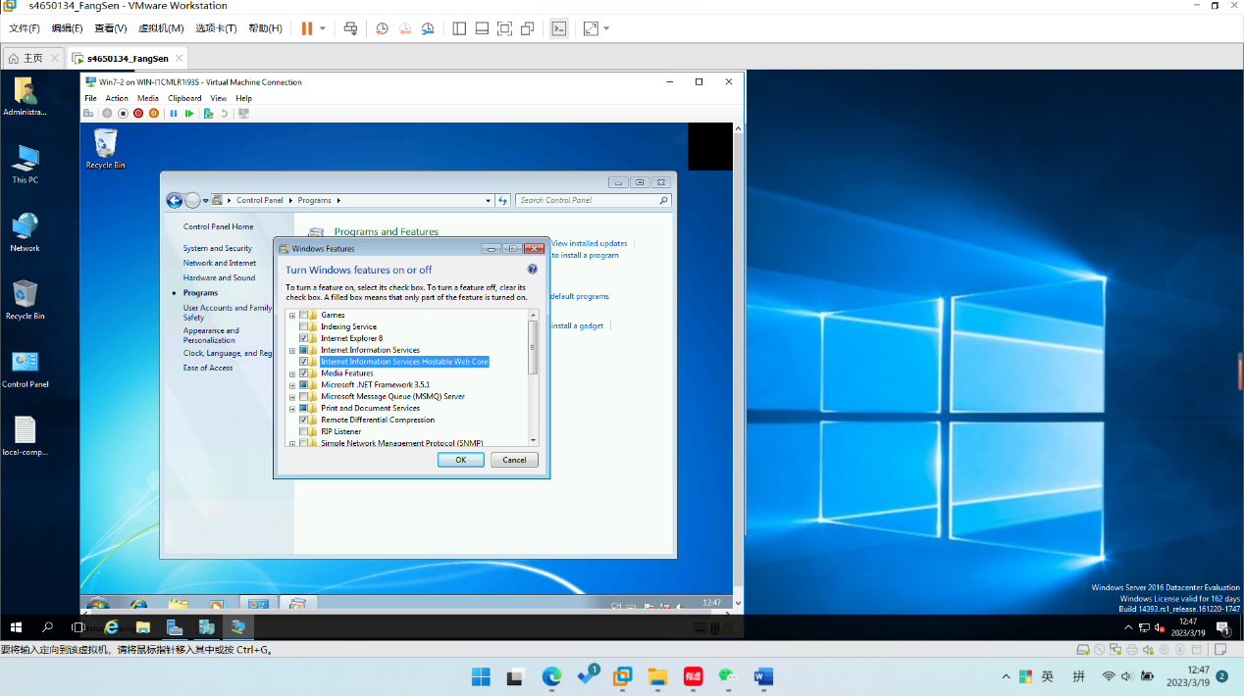

Figure

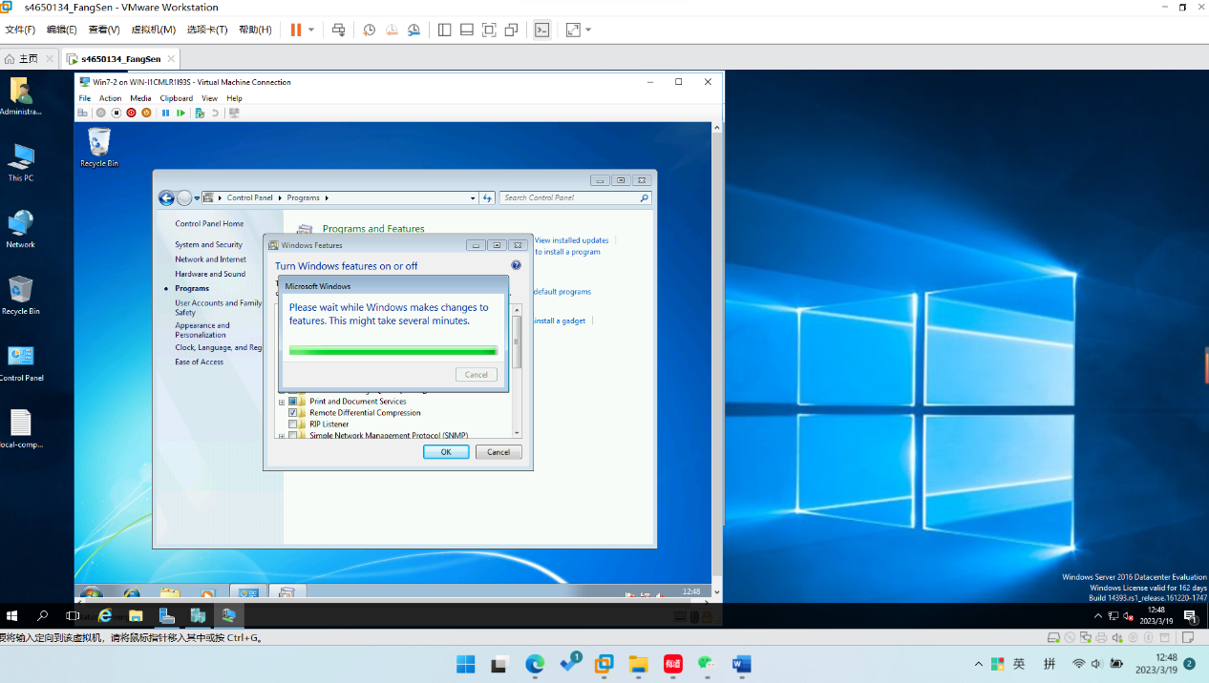

Figure

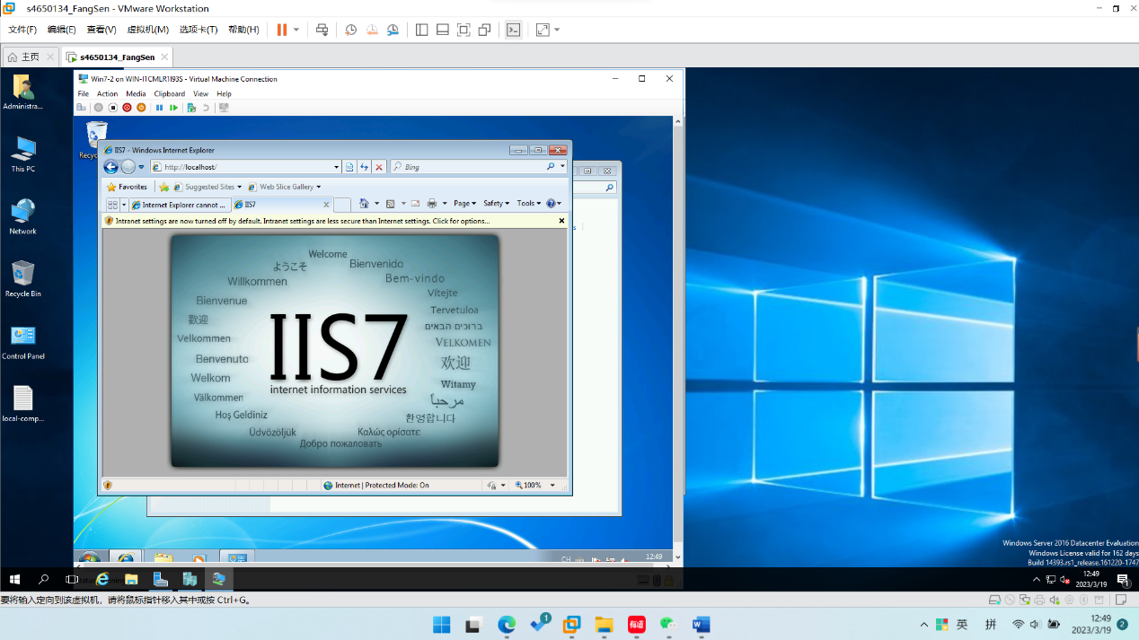

Figure